Step 1: Install Google Cloud SDK

If you haven't installed the Google Cloud SDK, you can download it from [here](https://cloud.google.com/sdk/docs/install).

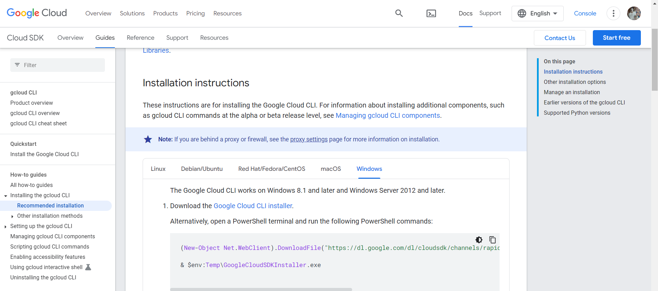

Step 2: Create a "Hello, World!" Python App

Create a New Directory: Open your terminal or command prompt and create a new directory for your project

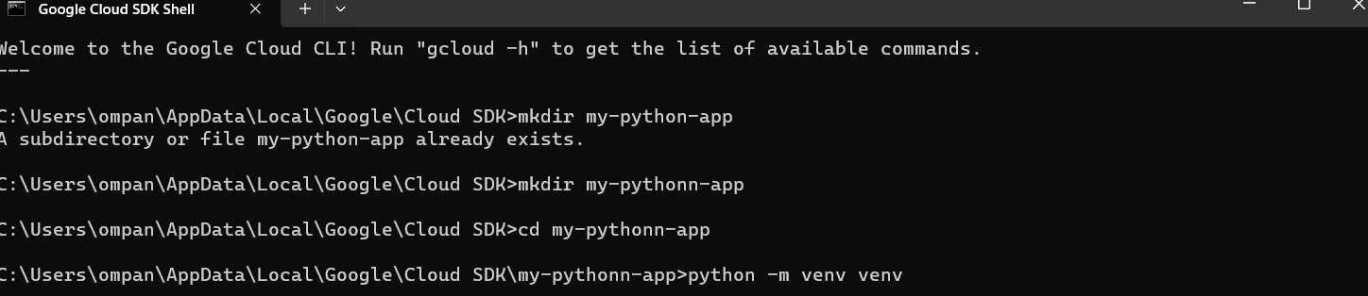



mkdir my-python-app

cd my-python-app

Step 3 - Install Flask: Install Flask, a lightweight web application framework for Python.

pip install Flask

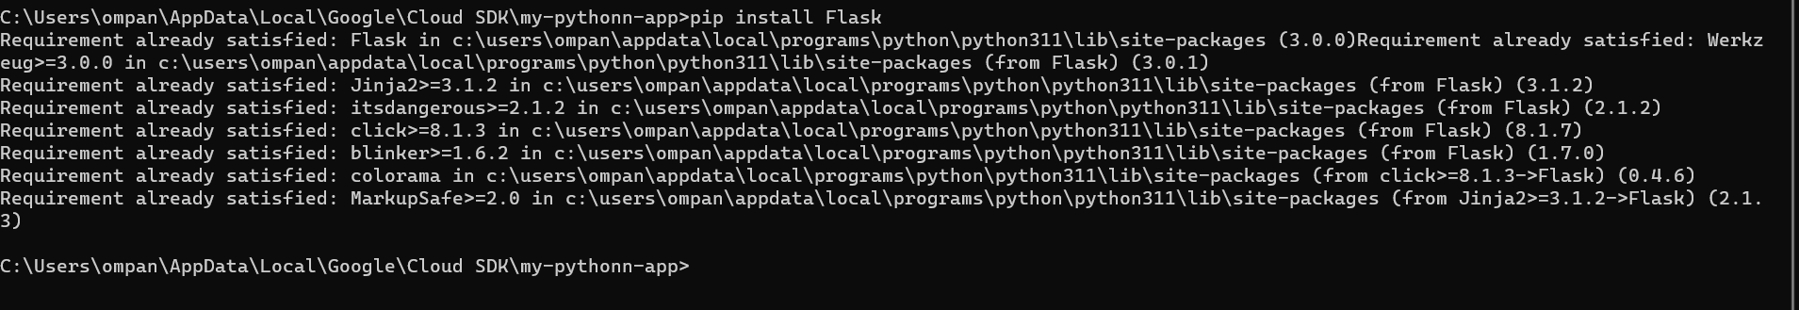

Step 4 :Create the Flask App: Create a file named app.py with the following content:

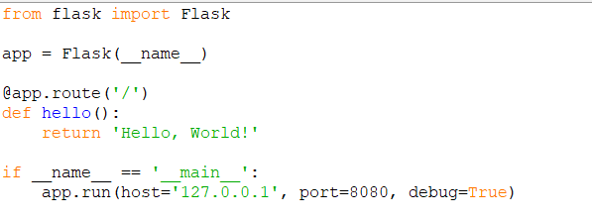

from flask import Flask

app = Flask(__name__)

@app.route('/')

def hello():

return 'Hello, World!'

if __name__ == '__main__':

app.run(host='127.0.0.1', port=8080, debug=True)

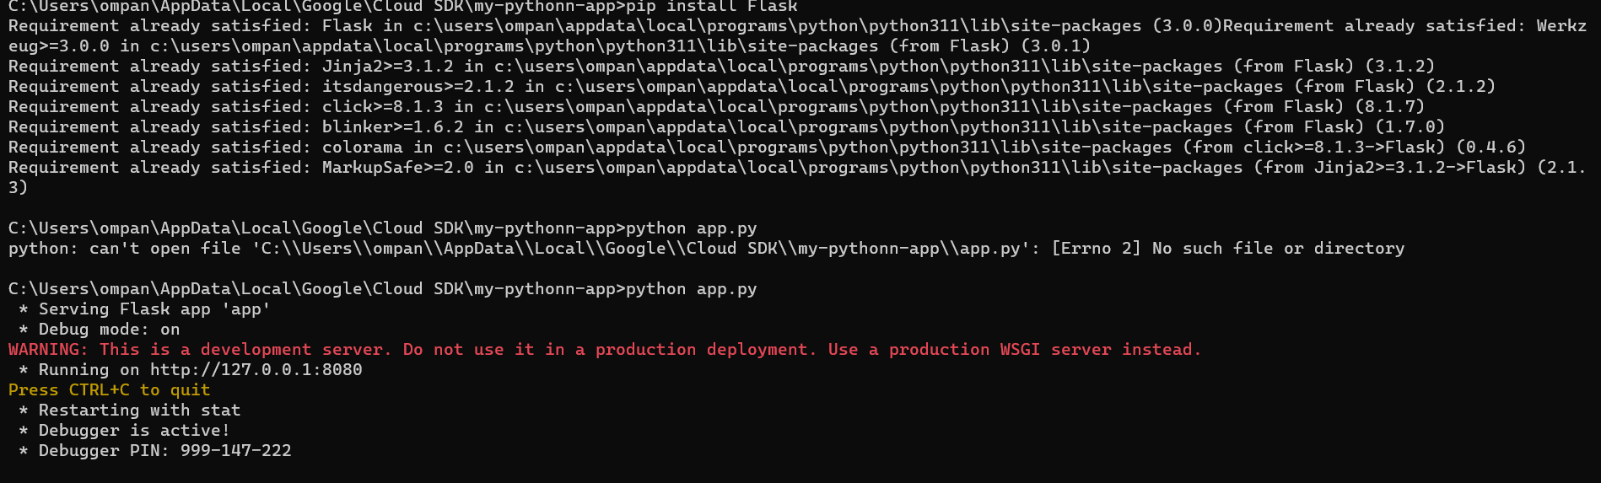

Step 5: Test the App Locally

Run the Flask app locally to make sure it works

http://localhost:8080 in your web browser. You should see "Hello, World!"

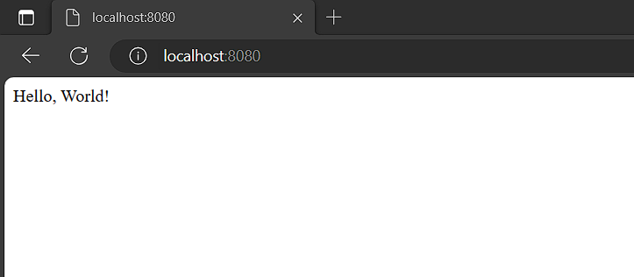

Step 6: Deploy to Google App Engine

Create app.yaml: Create a file named app.yaml in your project directory with the following content:

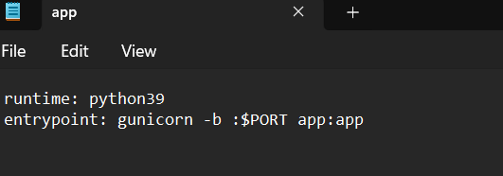

Deploy to App Engine: Deploy your app to Google App Engine.

Command - gcloud app deploy

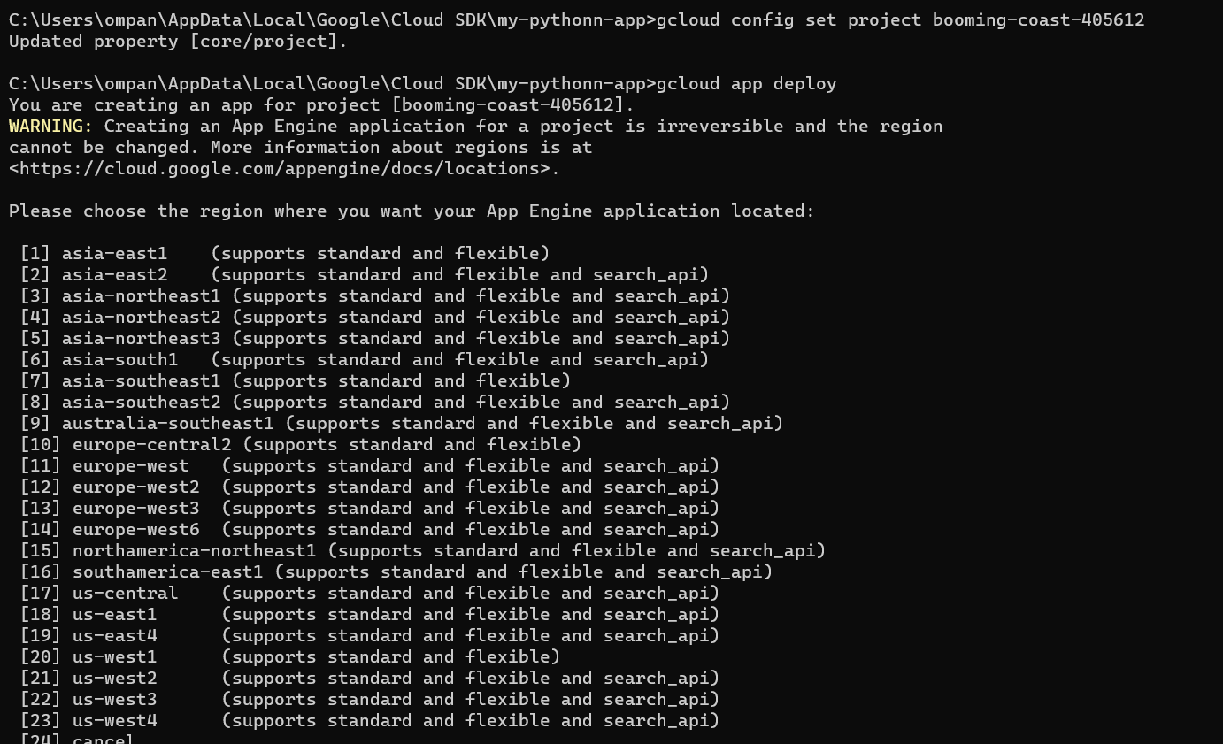

STEP 7

Open the [Google Cloud Console](https://console.cloud.google.com/).

Navigate to "IAM & Admin" > "IAM."

Find the thatswhatshesaid976@gmail.com account.

Click "Edit" (pencil icon) next to the account.

Add the App Engine Deployer role (roles/appengine.deployer).

Click "Save."

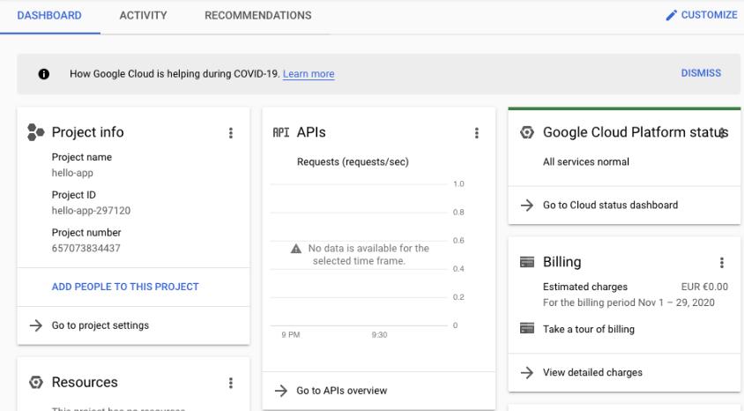

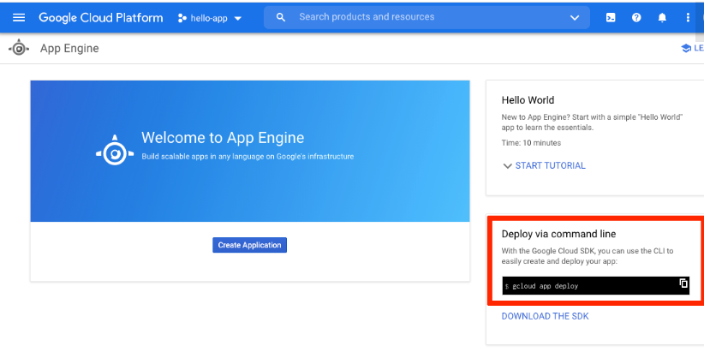

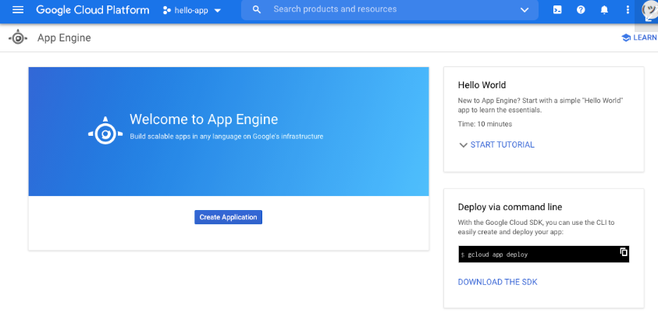

The gcloud command-line app already provided you with the command that you need to run. Type it into your terminal:

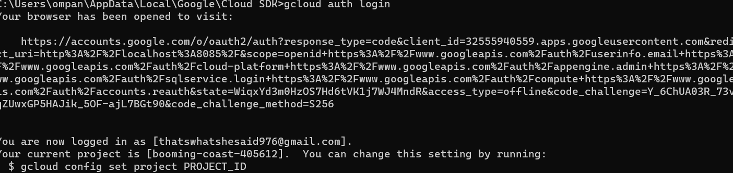

This will start the authentication process by generating a validation URL and opening it up in your browser. Complete the process by selecting your Google account in the browser window and granting Google Cloud SDK the necessary privileges. After you do this, you can return to your terminal, where you’ll see some information about the authentication process: